Travelling with Lithium batteries:
- Spare batteries can cause fires if not carried properly.
Wheelchairs / Mobility aids with Lithium batteries
- You should contact EGYPTAIR sales office or our call center at least 48 hours in advance of your flight to let us know about your request.

- EGYPTAIR accept all types of battery-powered wheelchairs as checked baggage such as wheelchairs with dry cell battery, gel cell battery, or non-spill able electric storage batteries. (WET BATTERY IS NOT ACCEPTED)

- Lithium-ion battery-powered wheelchairs or other similar mobility aids may be carried as checked baggage, provided that the battery must be of a type which meets the United Nations (UN) test requirements as specified in the UN Manual of Tests and Criteria, Part III Section 38.3. Certain safety procedures must be followed in order to comply with international air transport safety regulations and we will advise you of these at the time of booking.

- Please contact EGYPTAIR sales office or our call center for assistance and advise us about the weight and size of your wheelchair, the type of battery used for your battery-powered wheelchair and the lithium-ion battery watt-hours if your wheelchair is powered by a lithium battery.

- Lithium-ion battery powered wheelchairs or other similar mobility aids like scooters are permitted in air transport but subject to the following conditions:

- The batteries must be of a type which meets the requirements of which test in the UN Manual.

- It is recommended that customers make advance arrangements with each operator.

3- Most scooters have a key which can be switched to the off position, removed, and given to the customer for safe keeping. However, most power chairs are switched on and off with a push-button
- Lithium-ion battery powered wheelchairs will be accepted according to the following guidelines:
Wheelchairs with Fixed battery | Wheelchairs with Removable battery
The battery must not exceed 300 Wh | The battery must not exceed 300 Wh
A maximum of one spare battery not exceeding 300 Wh or two spares each not exceeding 160 Wh may be carried in the passenger cabin | A maximum of one spare battery not exceeding 300 Wh or two spares each not exceeding 160 Wh may be carried in the passenger cabin
Battery terminals are protected from short circuits, e.g. By being enclosed within a battery container | The battery must be removed
The battery must be securely attached to the wheelchair or mobility aid and accepted as checked baggage normally. | The wheelchair / mobility aid may then be carried as checked baggage without restriction
Electrical circuits have been inhibited (by means of switch) or disconnecting the poles and insulating them | The battery must be protected from short circuit by insulating the terminals (e.g. by taping over exposed terminals).
The mobility aids must be carried in a manner such that they are protected from being damaged by the movement of baggage, mail, or other cargo | The removed battery must be protected from damage (e.g.) by placing each battery in a protective pouch. The battery must be carried in the customer cabin.
 | Removal of the battery from the device must be performed by following the instructions of the manufacturer or device owner
How to determine The watt hours:

- if the battery you wish to ship is rated at 11.1 volts and 4,400 mAh per cell:
4,400 mAh is 4,400 milli-ampere hours. Since most batteries have a low ampere hour ratings, they are rated in milli-amperes per hour (mAh), one thousandth of an ampere hour (Ah).
Since a milliamp ere hour is one thousandth of an ampere hour, divide 4,400 mAh by 1000 to get ampere hours (Ah).
4,400 mAh ÷ 1000 = 4.4 Ampere hours
To determine the watt hours in this battery, multiply 11.1 volts by 4.4 ampere hours:
11.1 V x 4.4 Ah = 48.8 Wh

Lithium Batteries in electronic devices

- Lithium ion batteries exceeding a watt-hour rating of 100 Wh but not exceeding 160 Wh may be carried as spare batteries in carry-on baggage only.

- Lithium ion/Metal (any watt hours) e.g.: Hover boards, solo wheels, air wheels, Electric bike, Segway, Car battery, Underwater lamp etc., are not permitted.

- Lithium Ion: e-cigarettes, e-pipes, & other personal vaporizers, are not permitted except if installed in equipment. Recharging and used on board is prohibited

- Lithium Ion: Power bank (less than 20000 mAh not exceed 2 pieces, between 20000 - 32000 mAh not exceeds 1 piece, More than 32000 mAh Not Allowed). Recharging on board is prohibited.
- Lithium ion batteries, lithium metal batteries or power banks without any clear marks of the Watt-hour or lithium metal content or where the watt-hour rating can’t be calculated are forbidden.
- Procedures of Spare batteries at security points:
- The exposed terminals must be taped by plastic tape; or
- Placing them in plastic bag; or
- Leaving them in original retail packing.

- Whether a lithium battery can be carried by air or not depends on its configuration and its Watt-hour (Wh) rating (for rechargeable lithium-ion/polymer batteries) or Lithium Content (LC) (for non-rechargeable lithium metal batteries). Because we only fly to airports with thorough security checks, your items will be confiscated if they do not meet the requirements.

- For more information please check the chart below:
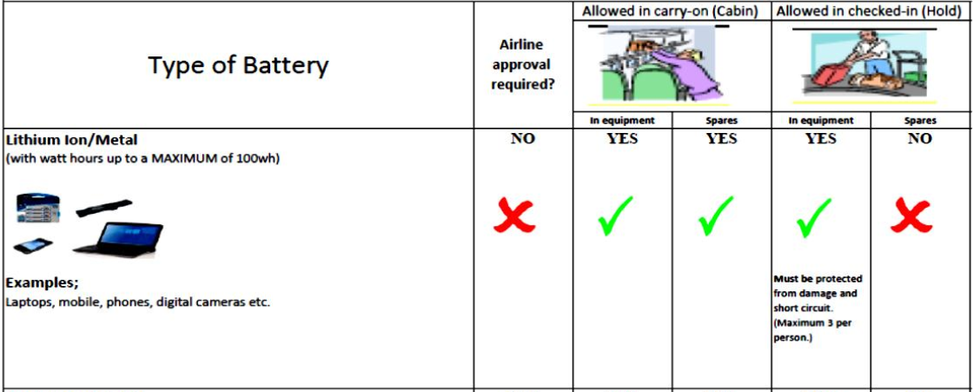

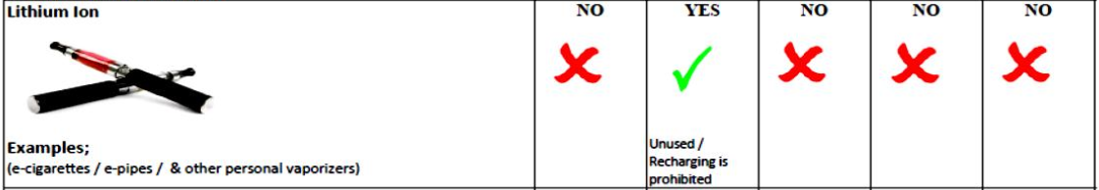
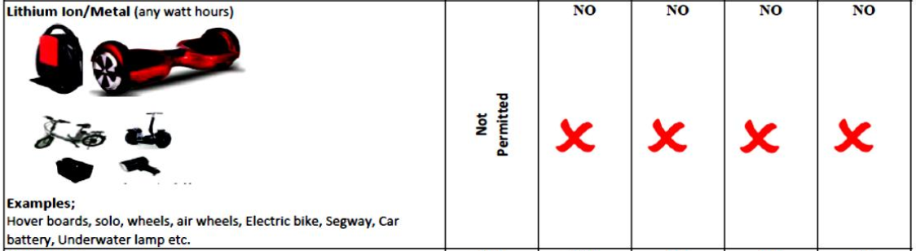
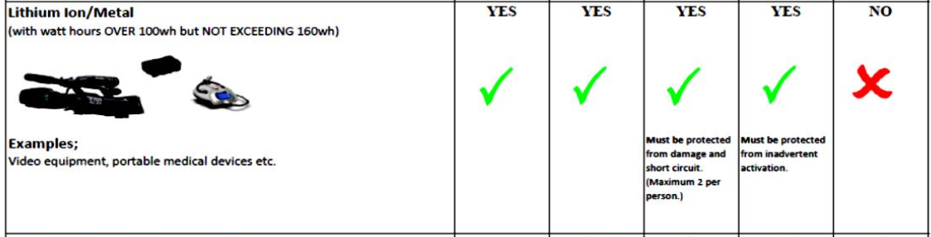
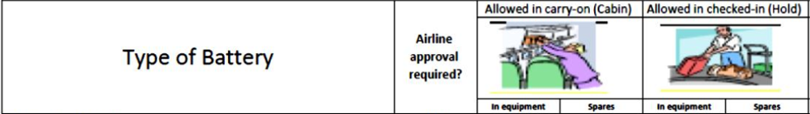

- Note: For safety reason electronic cigarettes are prohibited (Used / recharging on the aircraft) Electronic cigarettes cannot be carried in checked baggage.

- Note: For safety reason power banks are prohibited (used / recharging) on board.

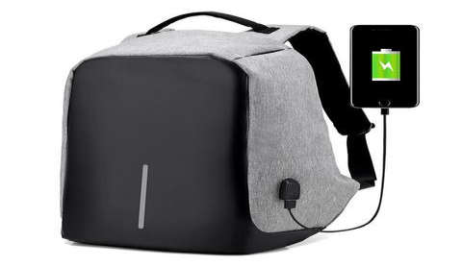
Smart Bags:
- Carriage of any “Smart Bag” powered with a lithium battery
Or lithium battery power bank will need to follow
Requirements as detailed below:

For cabin baggage | For checked baggage
Smart bags are allowed in the cabin if the battery is removable and within the EGYPTAIR cabin baggage size and weight limits. | Smart bags are allowed in checked baggage if the battery is removed and carried in the cabin
The battery can remain installed as long as the smart bag is completely powered off. | If the smart bag exceeds the cabin baggage size/weight limitations for the route and the battery is not removable, then the smart bag can’t be carried on an EGYPTAIR flight.
If the bag cannot be powered off or if the battery cannot be removed, the bag will not be allowed on MS flights.

